Circuit Analysis (Lab 7)
Experiment 7: Analysis of Operational Amplifiers Operations

Name: Muhammad Abdullah Registration No. 2025-CE-54

Date: ----- Grade and Signature: …………………

CLO4 | Construct amplifiers with operational amplifiers.
Psychomotor/ Affective | Level1  (1) | Level2  (2-3) | Level3  (4-5) | Level4  (6-7)
Report Marks (3) |  |  | Total marks (10)

Objective
The objective of this lab is to investigate the input to output relationship for inverting and non- inverting amplifiers.

Apparatus Required

Sr. No. | Apparatus | Range | Quantity
1 | Regulated Power Supply | Standard | 1
2 | Signal Generator | Standard | 1
3 | Oscilloscope | Standard | 1
4 | Digital Multimeter | Standard | 1
5 | Breadboard & Wires | Standard | As Required
6 | Resistors | 1k Ω, 2k Ω ,3k Ω | 3
Description
Operational amplifiers can be used in two basic configurations to create amplifier circuits. One is the inverting amplifier where the output is the inverse or 180° out of phase with the input, and the other is the non-inverting amplifier where the output is in the same sense or in phase with the input.
Both operational amplifier circuits are widely used and they find applications in different areas. When an operational amplifier or op-amp is used as a non-inverting amplifier it only requires a few additional components to create a working amplifier circuit.
Pin configuration of IC 741 op amp is shown below

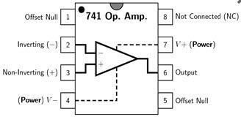
- Pin 1 is offset null.
- Pin 2 is inverting input terminal.
- Pin 3 is a non-inverting input terminal.
- Pin 4 is negative voltage supply (VCC)
- Pin 5 is offset null.
- Pin 6 is the output voltage.
- Pin 7 is positive voltage supply (+VCC)
- Pin 8 has no connection.

Precautions:
- Voltage control knob should be kept at minimum position.
- Current control knob of RPS should be kept at maximum position.
- Carefully utilize the oscilloscope channels and function generator.

Procedure for Inverting Amplifier:
- Wire up the circuit as shown in the figure below on the breadboard.
- Give the input to the inverting terminal of the op-amp and simultaneously display the input and output on the oscilloscope.
- Draw the input & output waveforms at the end of the lab.
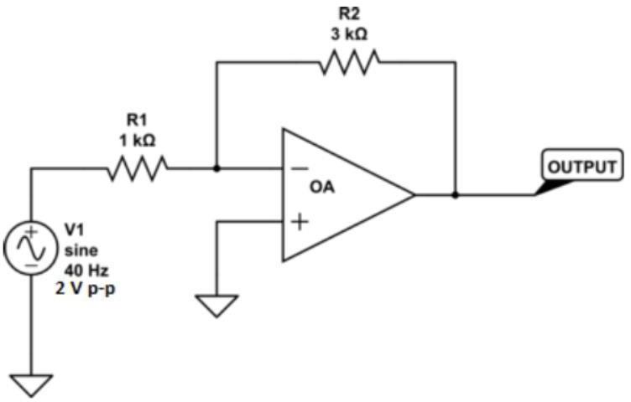

Procedure for Non-Inverting Amplifier:
- Wire up the circuit as shown in the figure below on the breadboard.
- Give the input to the non-inverting terminal of the op-amp and simultaneously display the input and output on the oscilloscope.
- Draw the input & output waveform at the end of the lab.

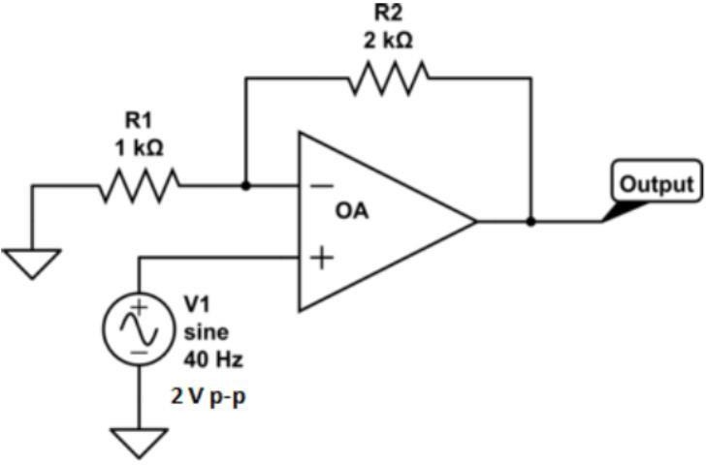



Result:
Figure 7: Input Voltage Signal Figure 8: Inverted Output


Figure 9: Non-Inverting Output

Post Lab Questions:

1. Define Inverting Amplifier.
An inverting amplifier is an operational amplifier circuit in which the input signal is applied to the inverting terminal.
The non-inverting terminal is usually connected to ground.
The output signal is 180° out of phase with the input signal.
It provides amplification with phase inversion.
The gain of an inverting amplifier depends on the input and feedback resistors.

2. Define Non-inverting Amplifier.
A non-inverting amplifier is an operational amplifier circuit in which the input signal is applied to the non-inverting terminal.
The output signal is in phase with the input signal.
It provides voltage amplification without changing signal polarity.
The inverting terminal is connected through a feedback network.
Its voltage gain is always greater than or equal to one.

3. What are the applications of inverting amplifiers?
Inverting amplifiers are used in signal processing circuits.
They are used in summing and scaling amplifier applications.
These amplifiers are commonly used in audio and communication systems.
They are also used in analog computers and waveform generators.
Inverting amplifiers help in phase reversal of signals.

4. What are the applications of non-inverting amplifiers?
Non-inverting amplifiers are used where high input impedance is required.
They are commonly used in buffer and voltage follower circuits.
These amplifiers are used in sensor signal amplification.
They are also used in medical and instrumentation devices.
Non-inverting amplifiers are useful in audio amplification systems.

5. What is gain of an amplifier?
Gain of an amplifier is the ratio of output signal to input signal.
It shows how much the amplifier increases the signal strength.
Voltage gain is commonly represented by the symbol $A_{v}$.
Gain can be positive or negative depending on the circuit type.
It is usually measured in decibels (dB) or as a numerical ratio.

6. How do you calculate the gains for inverting and non-inverting amplifiers?
The gain of an inverting amplifier is calculated as:
$$A_{v}=-\frac{R_{f}}{R_{in}}$$
Where $R_{f}$is feedback resistance and $R_{in}$is input resistance.
The negative sign shows phase inversion.
The gain of a non-inverting amplifier is calculated as:
$$A_{v}=1+\frac{R_{f}}{R_{1}}$$
Where $R_{f}$is feedback resistance and $R_{1}$is the resistor connected to ground.

18.

